1. Project Description
In Nigeria, grain milling is a critical activity for daily food preparation and local commerce. However, many small-scale grain millers continue to rely on outdated stone-grinding equipment. These systems are slow and prone to contamination from dirt and bacteria, leading to inconsistent, low-quality flour and an increased risk of foodborne illness. Rising energy costs and low productivity drive up production costs, placing financial strain on millers who often operate at subsistence levels (Source 1).

Nigeria presents a strong market and significant social opportunities for a grain mill, driven by high demand for affordable, small-scale grain milling, particularly in rural communities. More than 80% of farmers in Nigeria are smallholder farmers located in rural areas (top right of Nigeria), accounting for approximately 90% of national agricultural production. From a social perspective, about 85% of agricultural output is either consumed within households or traded locally in rural areas, while only 15% enters other market channels. This distribution has created a growing need for household-scale grain mills that reduce reliance on large, centralized milling operations. The proposed design allows individual components to be easily removed, replaced, and recycled, helping minimize waste and reduce long-term costs for users. Additionally, the use of locally available materials supports local economic development, improves food security, and lowers labor burdens (Sources 10, 11, and 12).

The primary reason this product is necessary is unreliable power grids in rural Nigerian communities. As shown in Figure 1, 40% of Nigerians lack access to electricity, and local farmers reported that grid electricity is effectively nonexistent in their communities, reinforcing the need for a fully off-grid solution. The project aimed to increase access to milled flour in those communities. Freshly milled flour also has better nutritional content than prepackaged flour. The difference between the two types of flour is monumental. Freshly ground flour has about 260 mg more potassium, which supports water balance in the body, supports muscle movement, and keeps the nervous system healthy. It also contains about 200 mg more phosphorus, which helps keep bones and teeth strong while supporting metabolic processes that convert food into energy. With cereals like wheat dominating the diets of many of these communities, this would support a healthier diet. (Sources 2 and 4).
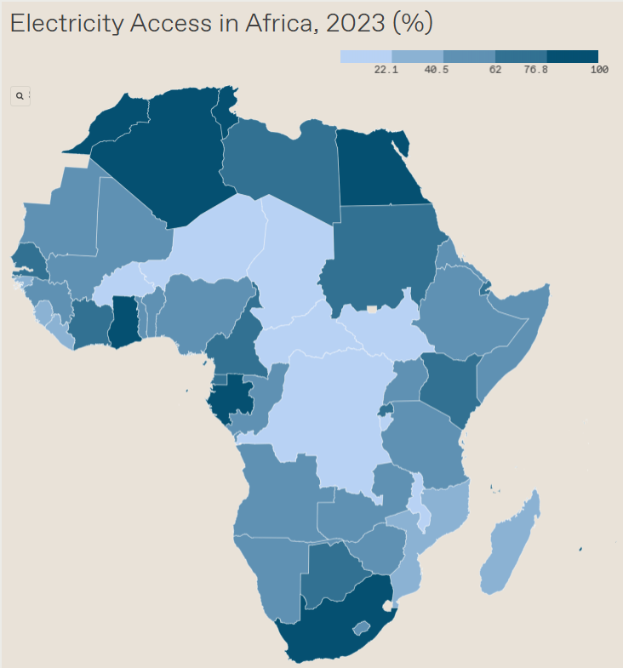
Figure 1. Power Access in Africa
Primary users will be families who grow their own grain in rural areas, as well as local farmers who lack electricity and need a powerless mill to mill their own wheat. Other stakeholders include the companies that first manufacture the product and the distributors who transport the mills from manufacturers to rural areas in Nigeria. And lastly, the people who actually sell the mills to the actual people. Also, depending on how it is manufactured, companies that make the specific parts for the mill would be involved, but only if the product's manufacturer doesn't make all the parts. (Source 8).
As shown in Table 1, this design promised to cost less than 50 US dollars, grind 1 lb of grain in 30 minutes, be smaller than 24x16x12 inches, weigh less than 15 lbs, and, lastly, have the funnel hold at least 710 cm³ of grain. Overall, this design will deliver a way to get fresh grain to people in food crises in Nigeria. This product will be especially beneficial for people who cannot afford to buy their own grain or do not have access to it due to infrastructure problems in their area.

Table 1. Project Metrics

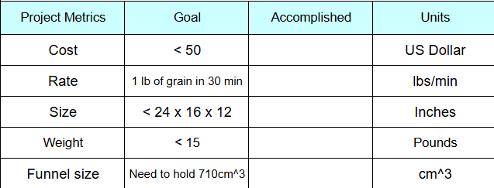

2. Customer Requirements
The customers for this product would be rural Nigerian families and small local farmers, as more than 80% of Nigerian farmers are small-scale farmers who grow their own grain and often live in rural areas with limited infrastructure and unreliable electricity (Sources 1 and 10). Currently, they use slower, outdated mortar-and-pestle methods (Figure 2), which are labor-intensive and physically demanding. These methods are inefficient and pose health risks, resulting in lower-quality flour (Source 4).
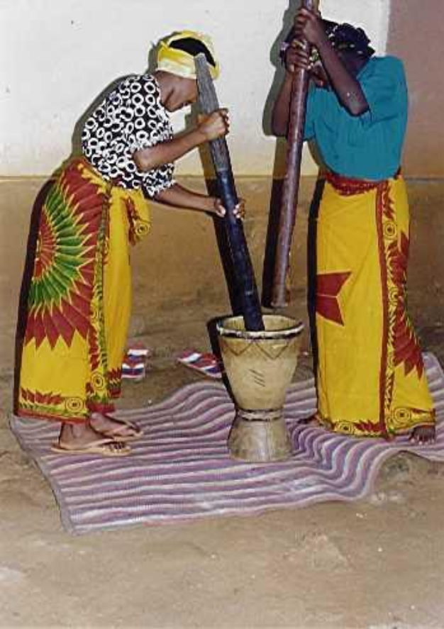
Figure 2. Traditional stone-grinding methods, which are currently used in rural parts of Nigeria

With energy prices rising and overall electricity supply limited, motorized mills are unrealistic and beyond the budgets of most individuals (Source 1). Making the trip to areas where industrial mills are to be implemented is a waste of time and money due to the lack of infrastructure and electricity. In one interview, an entrepreneur was asked whether the product would have high demand there. He responded with, “Yes, people in rural areas of Nigeria don’t have the money to spend over $100 on a grain mill, as the minimum wage is about $20 a month and hasn’t changed since 2019, so yes, many families in the area of rural Nigeria would be in high demand for your product." (Source 18)." As a result, some key customer requirements include low-cost, effective milling, both of which are extremely important (Source 17).

Some other requirements, which are not as demanding on the customer, would be ease-of-use qualities such as ease of cleaning or storage when not in use. Lastly, features like appearance and premium materials are wanted but are overall the least important, as they just care if it works and is effective. Table 2 shows these requirements, as well as others, and also lists significant competitors of the product, including other hand cranks and the still-current method of stone grinding. The table also shows how the competitors rank against the product, and that every competitor has their strengths and weaknesses, but the product's main advantage is its price.

Table 2. Customer Requirements and Market Analysis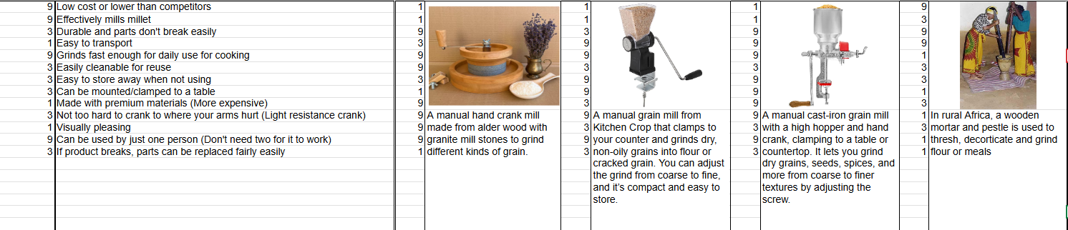

3. Specifications and Benchmarking
Some of the most heavily weighted specifications (shown in Table 3) associated with the customer requirements were affordability and man-powered operation. These specifications relate to the entrepreneur’s comment that many people/families in rural areas of Nigeria don’t have the money to spend over $100 on a grain mill. This also directly relates to the end user, as people/families living in areas with unreliable electricity need to rely on manual power. As a result, the team aimed to make the prototype fully manual, eliminating the need for electricity. To address affordability, the team set the prototype's cost at under $50. Competitor benchmarks showed that their products range in price from $55 to $250, reinforcing the need for a lower-cost alternative. By combining a hand-crank mechanism and aiming for a low-cost prototype, the team aims to outperform the competitors while still meeting the customers' essential requirements (Sources 2, 14-18).

Table 3. Ranked Specifications

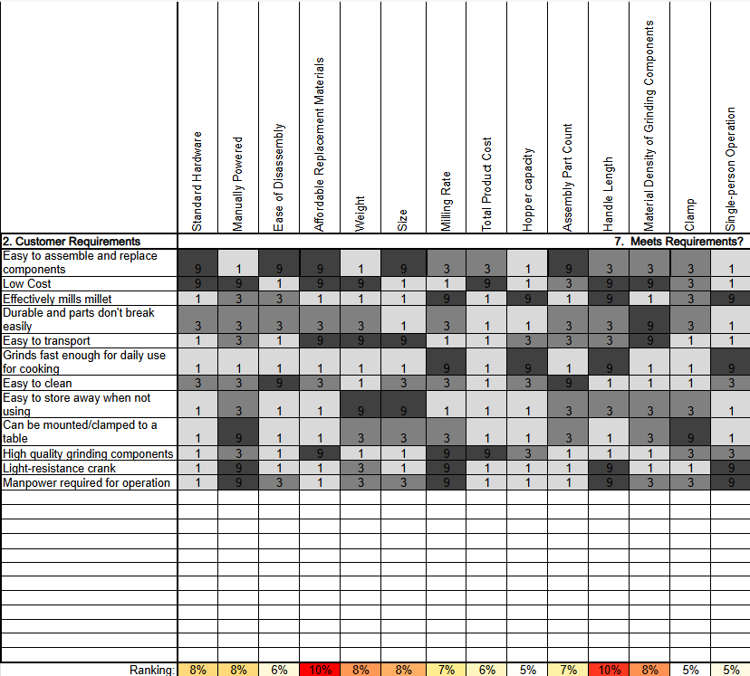

Other critical specifications were the overall weight, ease of material replacement, and mill size. These metrics relate directly to interviews the team had with the actual end user and the entrepreneur. The interview with the end user revealed that they have only about 4 cubic feet of storage space for the product. Based on this requirement, the team aimed to design the prototype to fit within dimensions of 2 ft x 1.33 ft x 1 ft, ensuring it fits in the end user’s storage space. To support ease of storage and overall use, the team aimed to keep the prototype under 15 lbs. Ease of material replacement was also a major requirement, particularly in rural areas of Nigeria, where resources are limited. The entrepreneur noted that wood would be available and easier to repair or replace in these areas. As a result, the team aimed to build the prototype primarily from wood. Benchmarking revealed that competing products range anywhere from 3 to 50 lbs, making it difficult to achieve the lowest weight; therefore, the team aimed for the prototype to be less than 15 lbs. Competitors were found to have similar overall dimensions and levels of repairability, so the team proposed the prototype to match the competitors (Sources 14-16).

Specifications that were hard to satisfy included low cost and the availability of high-quality grinding components while keeping those materials' prices down. Some competitors use cast iron, stainless steel, or a type of rock, such as granite or stone. These materials have densities ranging from 150 to 500 lb/cubic ft (Source 19). Premium materials with a higher density and quality needed for grinding components are expensive. Balancing the need for these materials' properties with their cost is difficult. Ease of disassembly can be difficult to assess without knowing the final design model the team will choose. The team wants the product to be very easy to take apart for storage, cleaning, and repair. These three things are important to us because some competitors use single-piece designs, where everything is one piece. The team wants to have access to every part of the product in case something breaks or needs cleaning.

The benchmarking data (shown in Table 4) was obtained by evaluating existing competitors and solutions available to users in rural areas of Nigeria, including traditional milling techniques and other modern hand-crank mills. These products were compared against key customer requirements, including affordability, man-powered operation, weight, and more. The team found that other hand-crank mills were expensive, with prices ranging from $55 to $250 and weights ranging from 3 lbs to 50 lbs. Competitors also showed dimensions similar to ours; the hand mill with a stone millstone measured 1 ft x 1 ft x 0.66 ft, with other competitors being fairly similar. Overall, benchmarking showed that existing products exceed cost limits, but the competitors, for the most part, have lower product weights than the team plans to have. The prototype aims to match competitors in size while significantly improving affordability and maintaining an acceptable weight for end users (Sources 9 and 14-16).

4. Design Concept
When thinking about design concepts, the most useful were the function analysis tools (function tree, morphological charts, function block diagram, and process flowcharts). These tools, especially the function tree (Figure 3), helped us break down the overall objective of milling grain into different functions and subfunctions. The function tree also helped us identify specific functions, such as loading grain, grinding grain, operating the machine with one person, and stabilizing the mill, along with the subfunctions related to those main functions. Creating the morphological charts enabled us to develop many different solutions for each sub-function. The morphological charts allowed us to explore many options for each, rather than locking into a single early design. Lastly, the function block diagram and process flowcharts (Figure 4) clarified the sequence of actions a user performs while operating the product. This helped clarify the order, which was taken into consideration when designing, making sure the team has every step addressed in each concept.

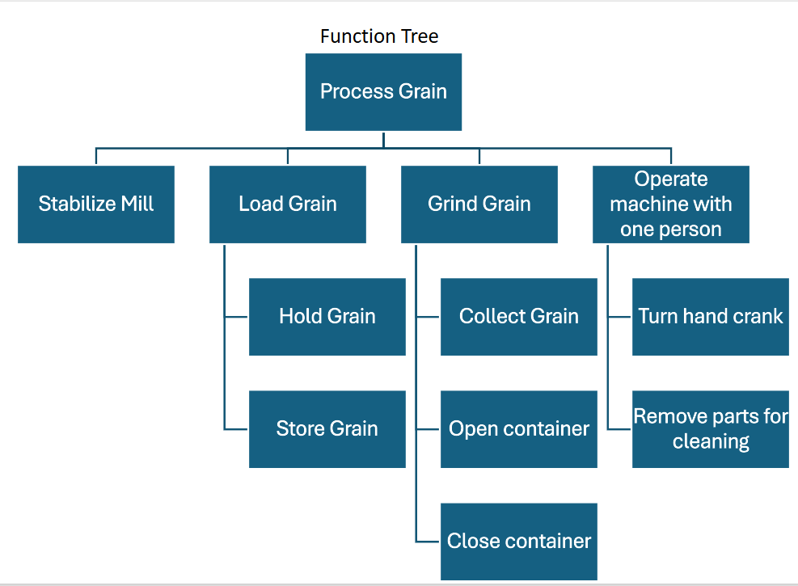
Figure 3. Function Tree Diagram
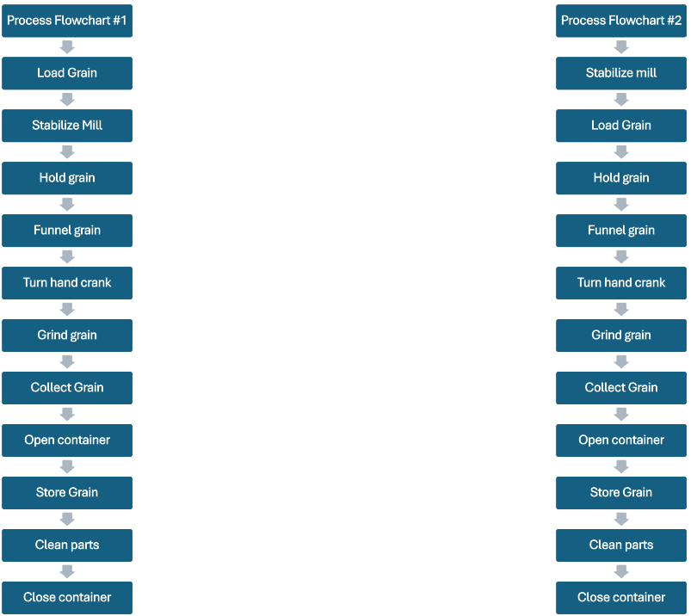

Figure 4. Process Flowcharts

The identified functions and sub-functions directly support the engineering metrics and features discussed in the QFD (Quality Function Deployment). Functions such as stabilizing the mill and operating the machine with one person address single-person operation, and the product is manually powered. Load grain, grinding grain, holding grain, and removing parts for cleaning relate to ease of disassembly, hopper capacity, and milling rate. By aligning the functions with QFD features, the team ensured the concepts were related and met the customers' requirements.
The first concept, shown in Figure 5, is the "hand-crank mill with stone millstones.” This concept was modeled on a competitor that the team currently has for the product (Source 14). This concept uses two stone millstones, powered by a hand crank. As the handle is cranked, the top millstone rotates while the bottom one is stationary. While the top one is rotating, it grinds against the bottom one, grinding the grain between them. After you are done grinding, remove the top stone and collect your grain.
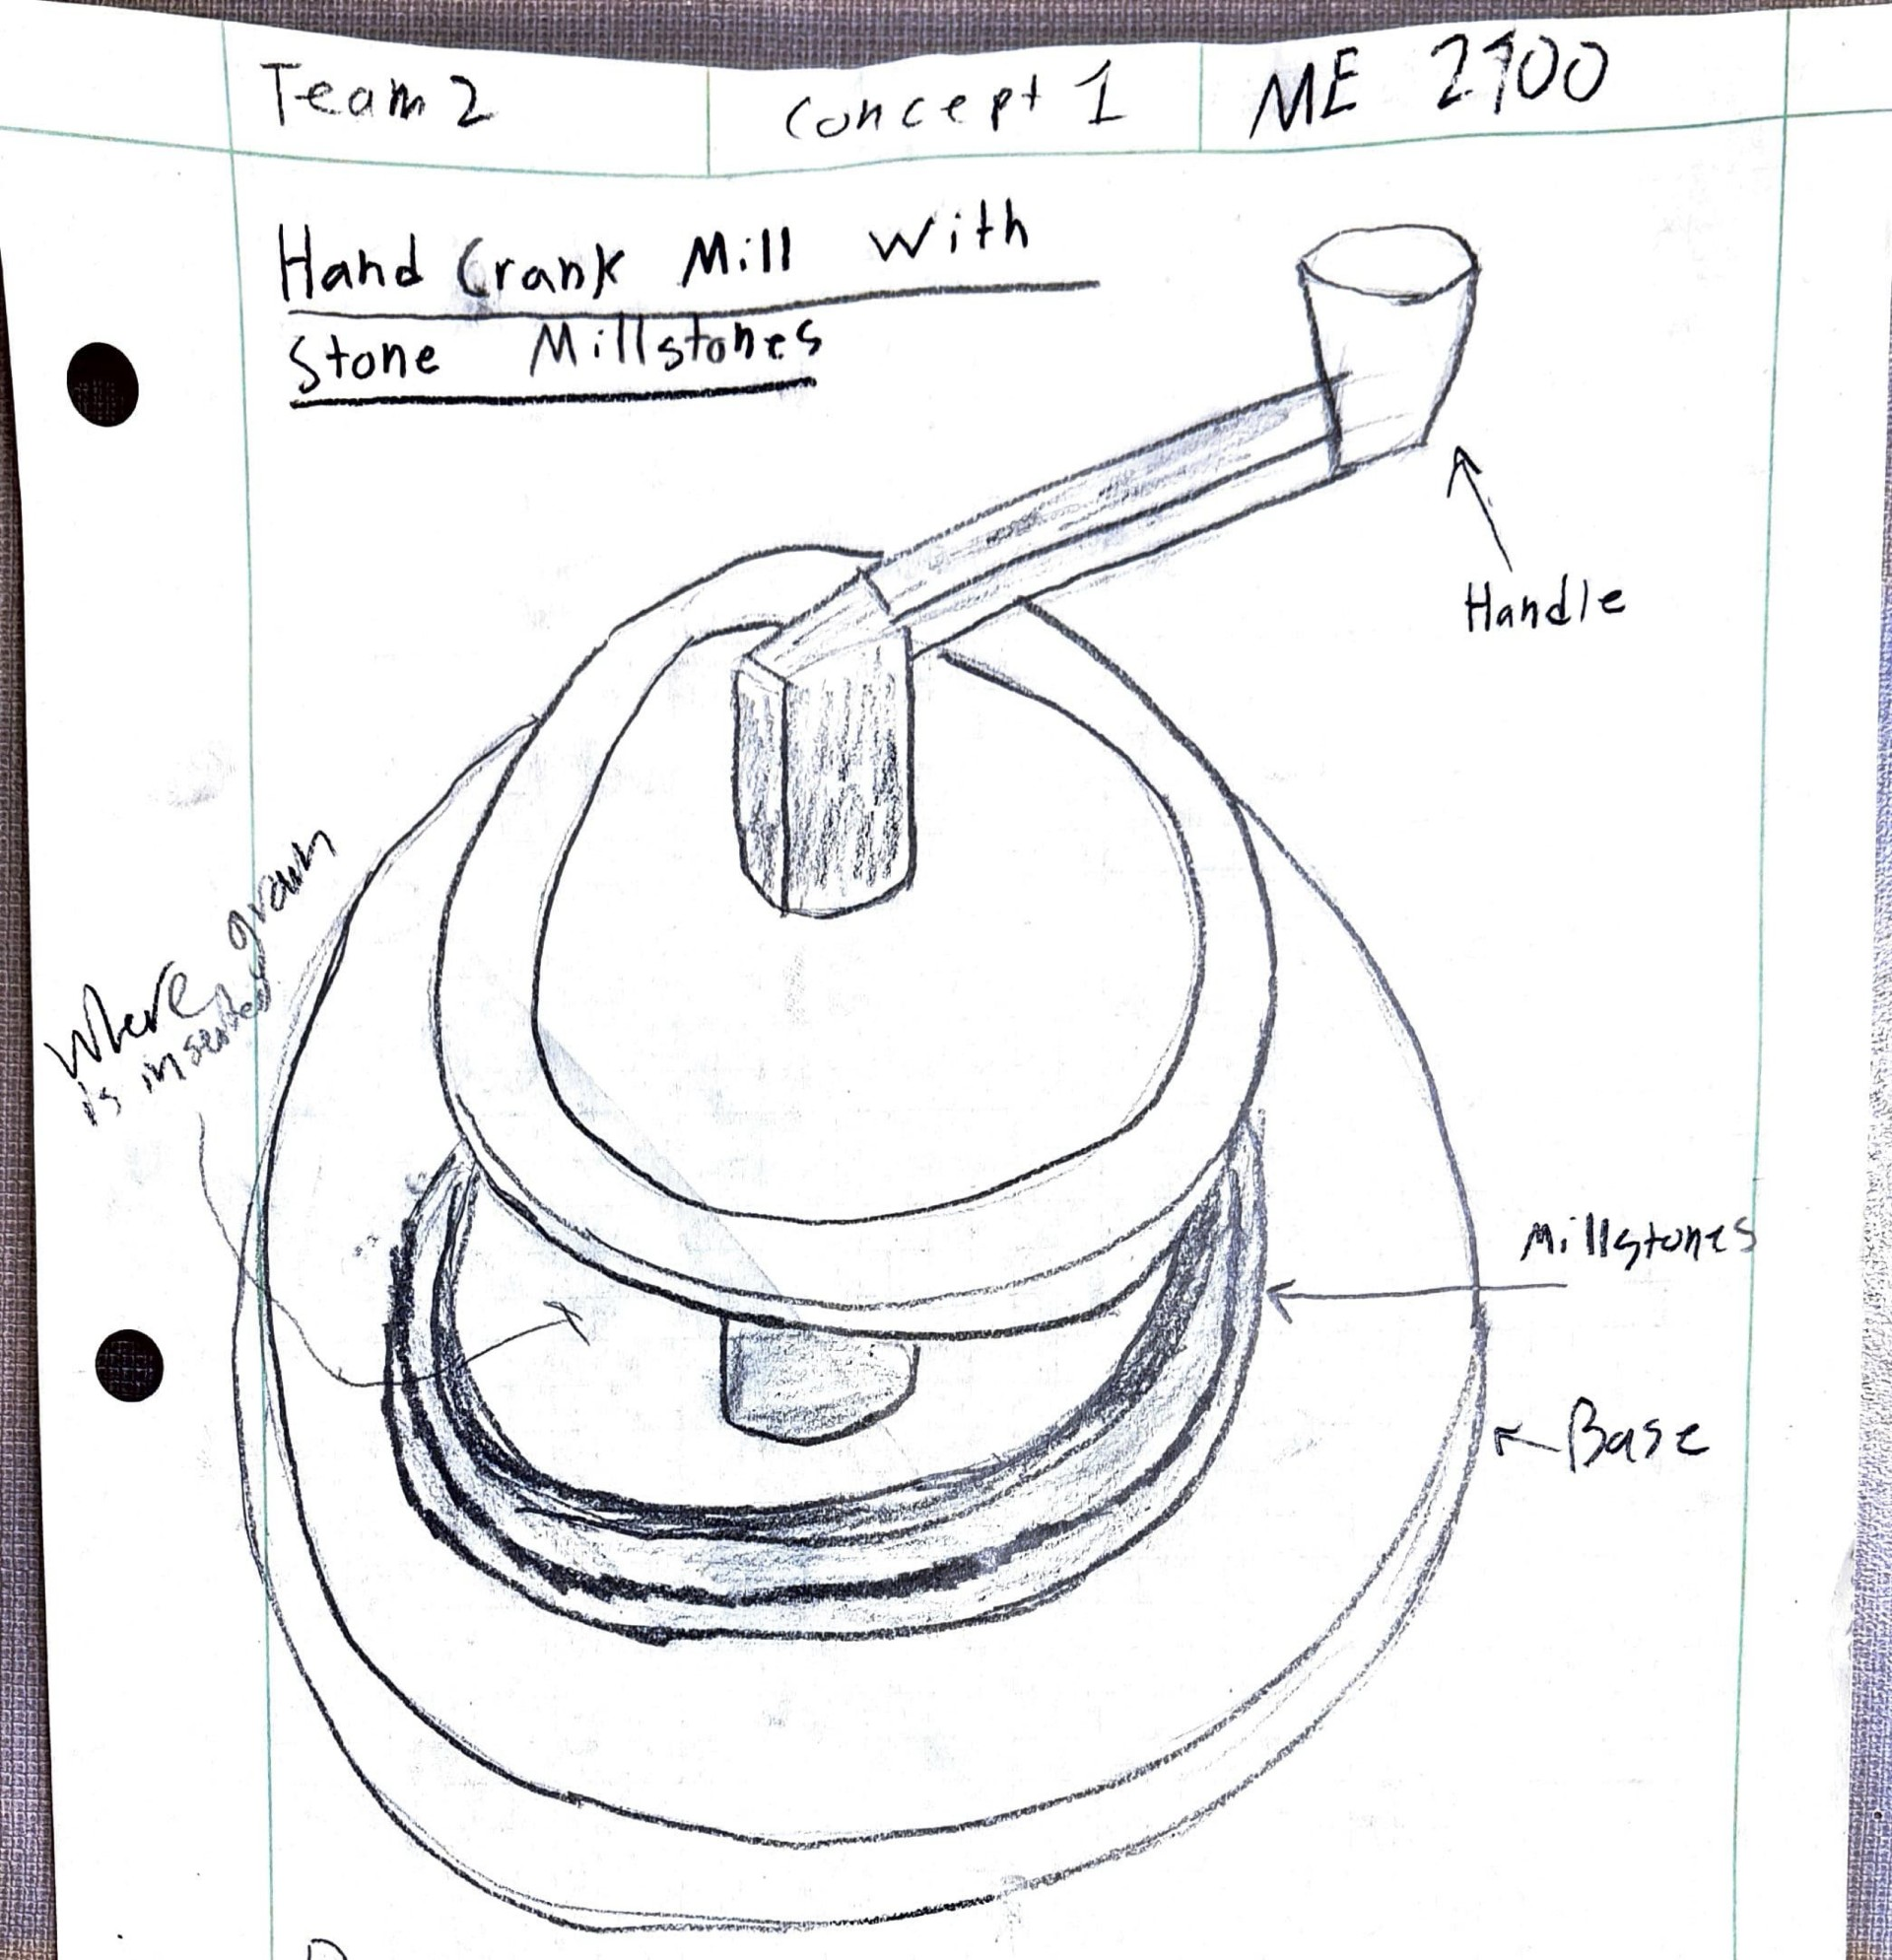
Figure 5. Hand-crank mill with stone millstones concept

The second concept, shown in Figure 6, is the “Hand-crank roller mill.” This concept was based on an idea the group had for an alternative way to make a grinder, distinct from many of the mills on the market. The typical grinding system of a cylinder grinder was replaced with two rollers with “teeth” that spin and grind the grain while the user cranks the hand crank. The hand crank is only connected to one roller, but on the other side of the mill, there will be a gear that will also turn the other roller. This concept also has a funnel where you load the grain, which falls into the actual grinders, and the ground grain then falls down the shoot into whatever container the user desires. Lastly, this concept features a table clamp with screw holes, so you can screw it into a table or clamp it to a table for ease of use.
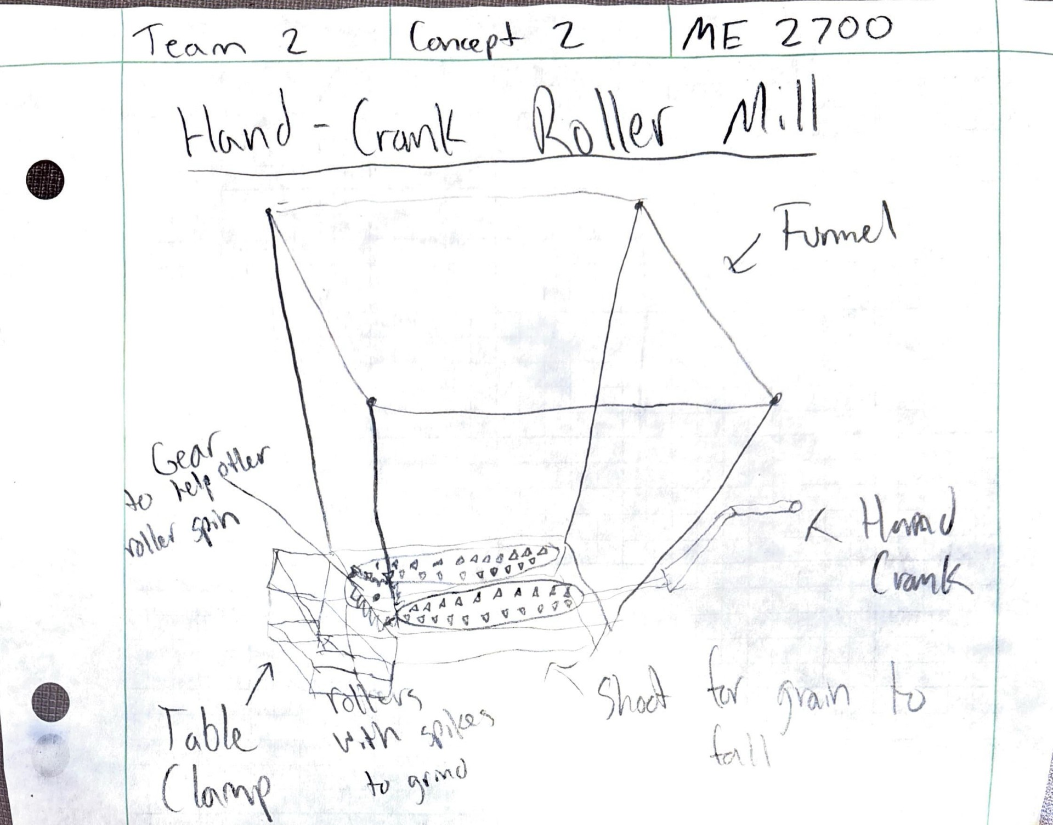
Figure 6. Hand-crank roller mill concept

The third concept, shown in Figure 7, is the "hand-crank mill with cylinder grinder.” This concept was also based on a competitor the team currently has (Source 19). This concept resembles a pretty standard hand-crank grain mill that has a cylindrical grinder. It has a hand crank that, when spun, spins the cylinder grinder. As the grain is fed into the funnel, it passes through the grinder's holes, is broken down into ground grain, and then falls down the shoot into the user’s desired container, which can be inserted at the bottom of the shoot. The base also includes 4 screw holes for mounting onto any surface for easier use.
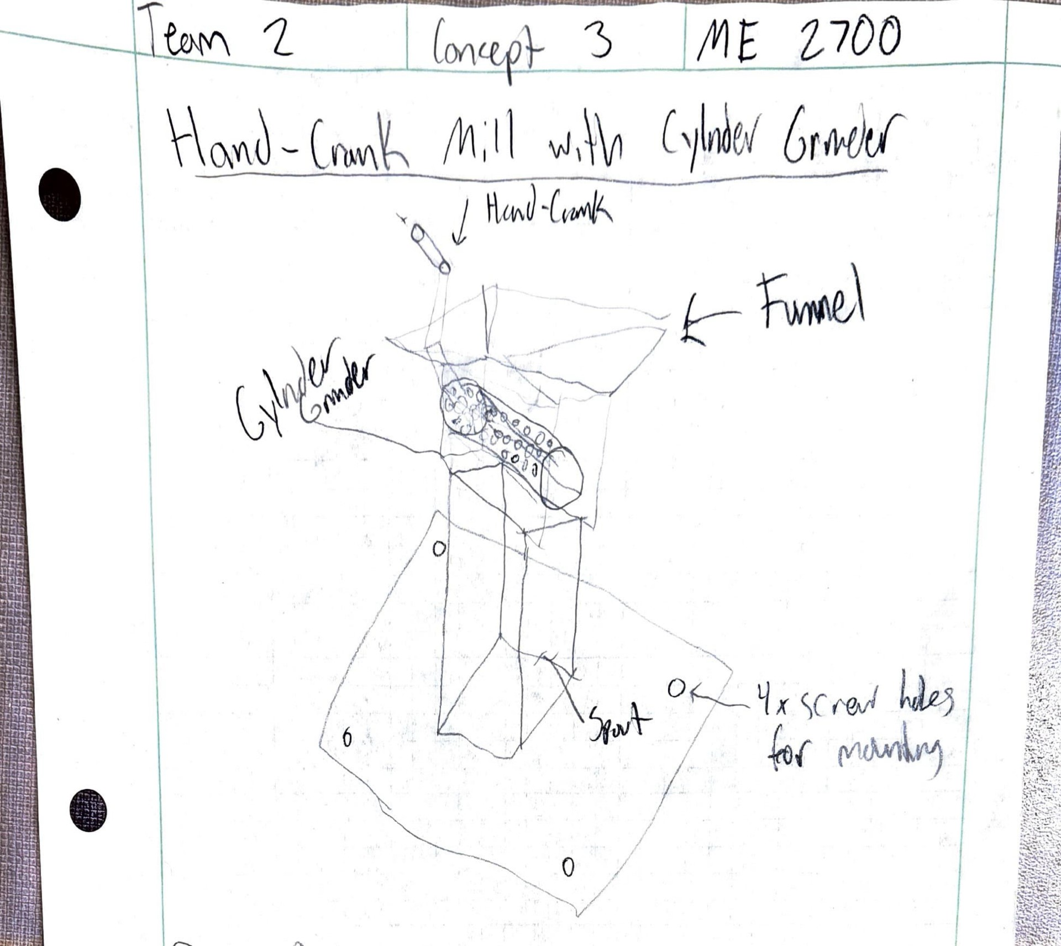
Figure 7. Hand-crank mill with cylinder grinder concept

The fourth and final concept, shown in Figure 8, is the “Hand-crank grain mill with container included.” This concept is fairly similar to concept 3, as it is based on one of the competitors (Source 19). This concept is also a pretty standard hand-crank grain mill that has a cylindrical grinder. It has the same mechanism as a hand crank, which spins the grinder when spun. As with the same process when you insert the grain, it goes down the funnel into the grinder's holes as it spins, breaking the grain. Then it falls down the spout into the built-in container, which can be taken out when full. This concept also includes a table clamp with two screw holes for mounting.

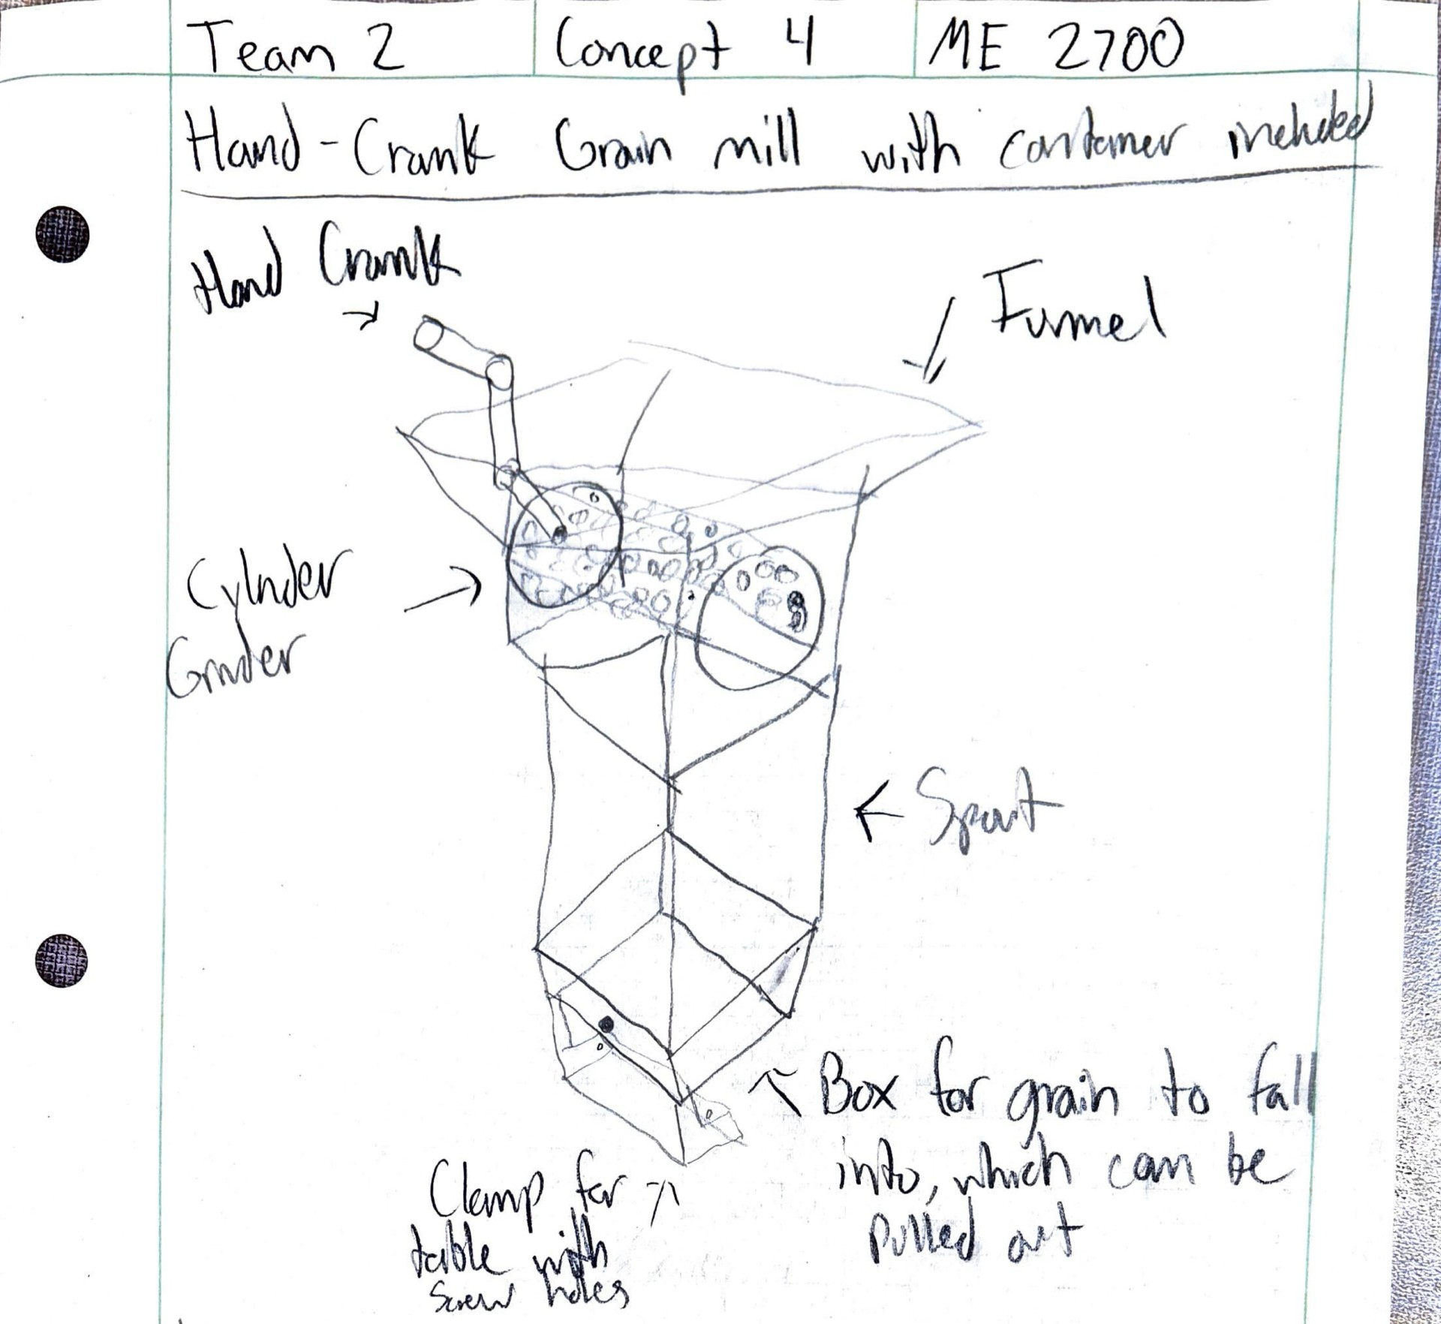
Figure 8. Hand-crank mill with cylinder grinder concept

During concept selection, each concept was evaluated against customer requirements and target specifications in the QFD (Quality Function Deployment). Starting with one of the concepts that was unselected, the "hand crank mill with stone millstones” that had two stone millstones, you put grain between them to be ground up. Ultimately, this concept was too expensive. It was a very simple design for grinding grain; however, the stone millstones were rather expensive to produce. The competitor’s cost $250, which was way over the desired range. Also, the concept lacked several other customer requirements, such as ease of assembly and the ability to be clamped/mounted to a table, ultimately leading to its non-choosing (Source 14).

The “hand-crank roller mill” was a very basic design with two rollers fitted with spikes to grind grain, and a large funnel to hold a lot of grain at a time. This open funnel concept made it easier to assemble and disassemble, thanks to its open design. This also made it easy to clean. However, given its size, it would not meet other customer requirements, such as being easy to store when not in use and easy to transport, both of which are very important, as the customer only has a limited amount of space to store it. This led to this concept not being chosen (Source 15).

The third concept, the "hand crank with cylinder grinder,” was a very basic hand crank mill based on another competitor's design. It had a funnel system into the grinder and then a chute where the grain would fall shortly after. It was also a very simple design, like the other two, with many benefits, including effective milling, durability, and ease of cleaning. The downsides to this concept were that it was difficult to store, transport, assemble, and disassemble. This also led us not to go with this concept (Source 15).

Lastly, the concept selected (shown in Figure 9) was the “Hand-Crank Grain Mill with Container Included.” This concept was fairly similar to the "hand-crank with cylinder grinder" and concept 4, except some changes were made to improve it. It still had that funnel system into the grinder and then a shoot; however, it now had a container for the grain to fall into, just to make it easier to use. Also, since one of the biggest cons of the other concepts was size, shrinking this one down so it's much easier to store away when not in use and to transport overall was what occurred. This also has parts similar to the other concepts, but since it is smaller, it would ultimately cost less, which is a major requirement for the customer. Overall, the challenge of this design will be to maintain the mill's effectiveness while shrinking its size and still meeting all customer requirements. Reducing the mill's size may also shrink the grinding area, ultimately slowing the mill rate and causing resistance in the hand crank. Overall, just trying to keep everything the same as if it were larger, just scaled down (Source 15).

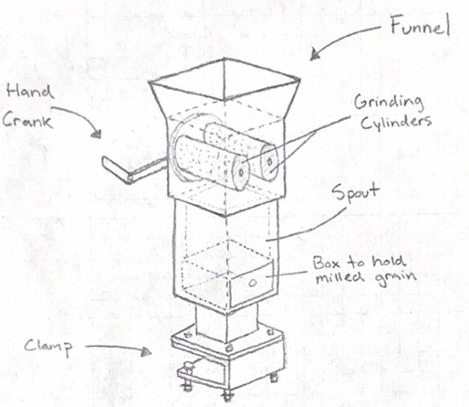

Figure 9. Hand-crank mill with cylinder grinder concept

The primary target specifications for this final concept were that the design weighed less than 15 lbs, cost less than $50, measured less than 2 ft x 1.33 ft x 1 ft, and had a milling rate of 8 lb/min. The strength of this data was that most of it, such as cost, size, general configuration, and weight, was based directly on the competitors, which ensured the team had a solid basis for specifying the concept. This allowed us to set a realistic and achievable target for the concept that reflects customer requirements. However, a weakness of the data is that some of the specification targets relied on estimates. These specifications focused mainly on the milling rate, user effort, and other less important factors. While the data was sufficient for initial concept comparison and selection, further prototyping and experimental testing will be necessary to validate and refine the final engineering specifications (Sources 9 and 14-16).

5. Function, Failure, and Analysis
The first mathematical model (shown in Table 4) described the mill's input system, which initiates the milling process. The only input to this model is based on two assumptions: the hopper volume equals the hopper capacity, and the specific weight is constant at 48.69 lb/ft³. The pouring force F = 65.44 lbf was calculated as F = yV, where y is the specific weight, and V is the volume. The control variable was hopper capacity, set to 5 cups, which the team converted to V = 0.04178 ft^3; this was the other value used in the equation. This model aligns with the product specifications because it uses the hopper capacity of 5 cups and converts it to volume, which the team uses in the calculations (Sources 25 and 28).

Table 4. Mathematical Model 1
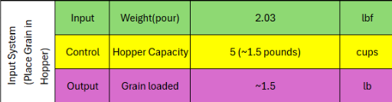

The second mathematical model (shown in Table 5) described the system in which the mill grinds grain and how user force is converted into torque and rotational speed to drive the mill. This model assumes a constant milling flow rate of 3 lb/min and a constant energy requirement of E = 8370 ft · lbf/lb. This is then used to calculate the power needed to mill, where P = E(flow). Also, assuming the crank radius is 3 in, the required user input will be calculated as F = P/(r · w), where P is the power, r is the radius, and w is the rotational speed. The control variables in this model are the cylinder radius and the torque, which is calculated as T = Fr, yielding a torque of 66.61 lbf · in. The rotational speed was calculated as w = 2 rad/rev × 60 rev/min, yielding 376.99 rad/min. The corresponding output time is 3 lb/min as well. This model directly ties to the product specifications because it quantifies the user effort required to achieve a targeted milling rate (Sources 26 and 27).

Table 5. Mathematical Model 2
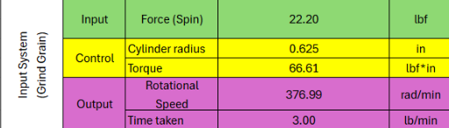

The third mathematical model (shown in Table 6) shows the system that removes the grain from the container. The inputs for this model are the grain density and the force required to pull. For this model, the team assumes the grain density is y = 48.69 lb/ft³, the container volume is at its rated capacity, and the pulling force is about 3 lbf. The team set the control variable to 5 cups for the container volume, which converts to V = 0.004178 ft³. The pulling force was F = 3 lbf. This is assisted by gravity; it drives the flow from the container. From the equation F = yV, the team can predict the amount of grain available for milling based on density and volume. From the equation, the output is 1.5 lb of grain collected. This indicates that there is a practical transfer efficiency of the container and milling mechanism. This model directly ties to the product specifications because it relates to human input power, specifically the pull force (Sources 25 and 28).

Table 6. Mathematical Model 3
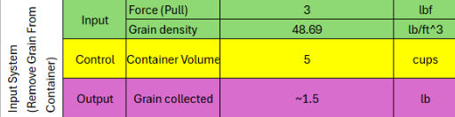

Due to the project’s constraints on total storage capacity, the mill's size and weight become the primary priorities and dimensional benchmarks for other functions, primarily affecting hopper capacity and overall mill stability. In addition, the targeted customers of this design also put a limitation on the total production cost to be affordable and reasonable, which also has negative impacts on how large the hopper capacity can be and the material density of the grinding components, and somewhat puts more pressure on the stability of the mill by having fewer components or thinner materials for this part. In compensation for these restrictions, the design has other features that outweigh the disadvantages for customers. It is also designed to be operated by one person, so it does not require any additional electricity or equipment. With locally sourced materials and easy assembly and component replacement, the prototype will be made of plywood, using standardized bearings and bolts to reduce wear-and-tear and improve overall performance and build quality. (all shown in Table 7).

Table 7. QFD Trade-offs Analysis Table
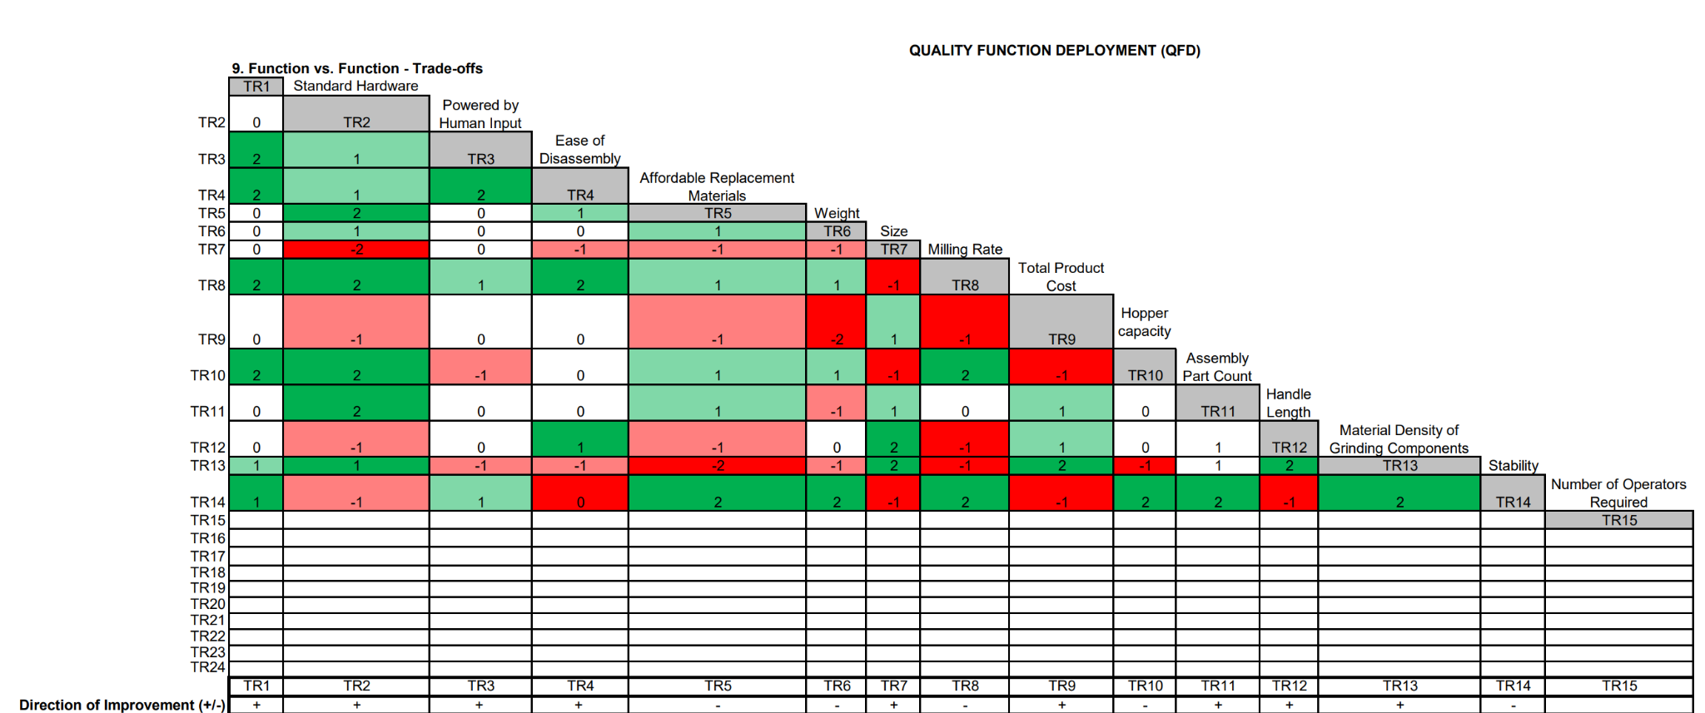

A couple of failure modes were definitively defined in the DFMEA (shown in Table 8-9). The highest RPN the team discovered (RPN = 189) was the stabilization clamp breaking. Due to constant stress and frequent use, the clamp is more prone to breaking over time. To minimize this failure, the team would either use a higher-quality material or test the clamp to properly dimension it, thereby maximizing the component's lifespan in the grain mill. These tests could include using stronger straight-grained wood or reinforcing critical components to make them sturdier. Another significant failure mode identified in the DFMEA (RPN = 189) was the central grinding component breaking. The roller grinders need to be made of a high-quality material, not only to properly grind grain but also to sustain consistent use and not break after the first use. A control system to prevent these rollers from breaking is to test different metals to find the most durable while staying within budget. The user can inspect the rollers after each use to ensure there are no impurities or failures in the grinding components. The last major DFMEA outlier is the milling gears the team will use to turn the grain grinding rollers (RPN = 160), which may break or jam. These gears are a key component and are under consistent stress because they turn the grinding component. A solution to this issue is to use thicker gears during manufacturing to increase the stress required to break them, and then test them to find the best fit for the product. The user can also regularly check the gears for any failures that may appear (Source 29).
Table 8. DFMEA 1/2
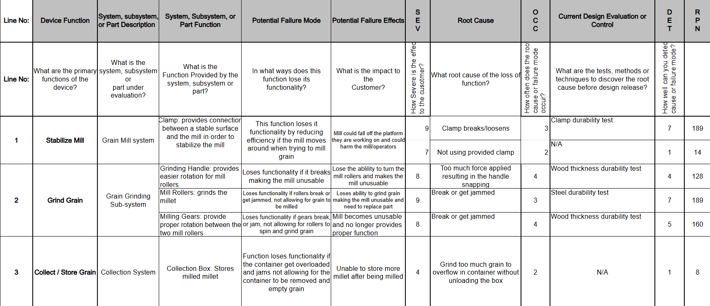

Table 9. DFMEA 2/2
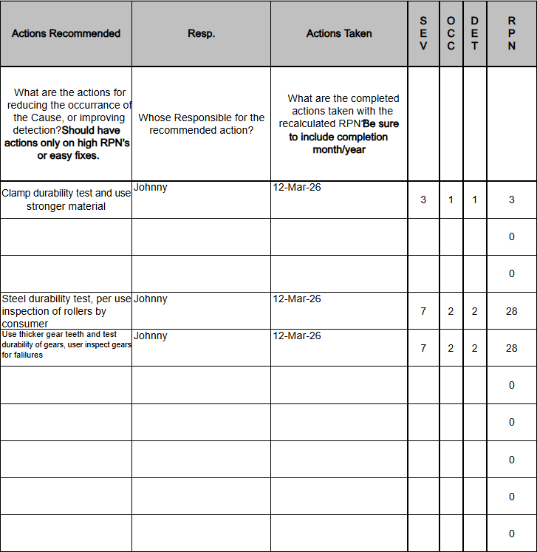
6. Prototype Fabrication Process
The main assembly of the grain mill prototype consists of eight subassemblies. The main subassembly of the full assembly is the grain mill shell (shown in Figure 9). The shell subassembly is a rectangular box with a funnel at the top and a space at the bottom for a container to be inserted, and a space at the top for the roller plate to be inserted later. Most of the parts in this subassembly have distinct holes for hardware insertion and for assembly. This subassembly only uses basic woodworking equipment (table saw, miter saw, and drill press). The subassembly is assembled using the MPI shown below (Figure 10).
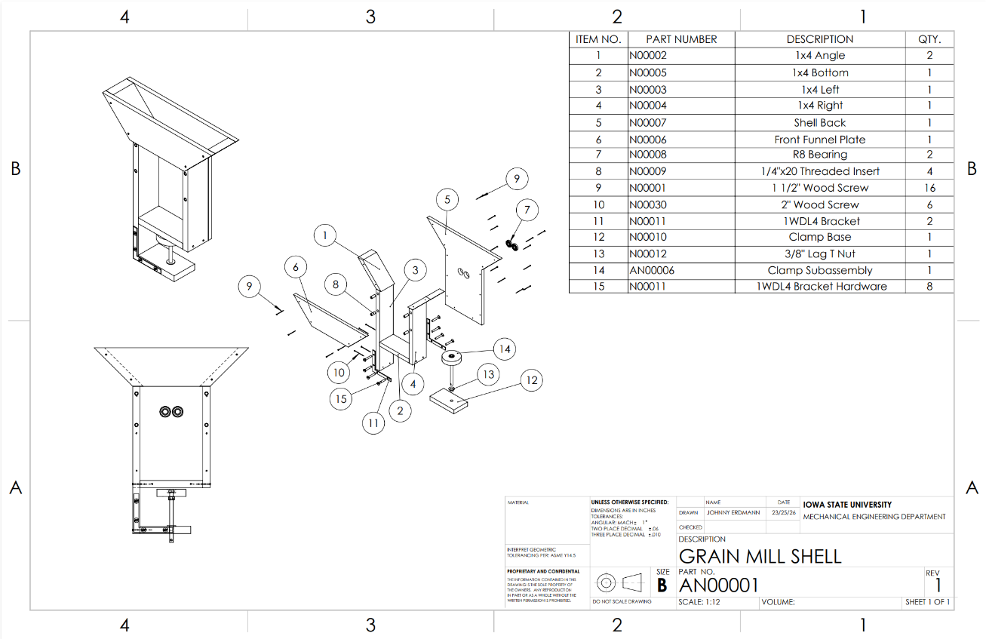
Figure 9. Grain Mill Shell Subassembly

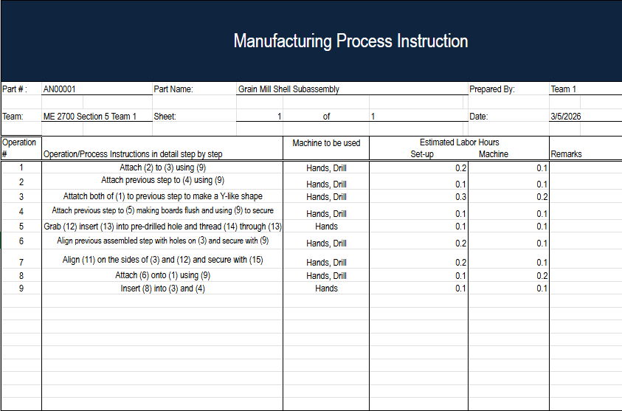
Figure 10. Grain Mill Shell MPI
Similarly, the second subassembly, the container subassembly (shown in Figure 11), uses basic woodworking equipment (a table saw, a miter saw, and a drill press). The container subassembly, however, is the container that will be inserted into the shell, as specified above. It is a fairly simple box with a little siding on the front, so it fits flush into the shell. It also has a screw drilled from the inside to the outside, serving as a small handle for the user to pull to open. As with the shell, most parts have holes drilled so hardware can be inserted and the subassembly assembled. The process for assembling it is also shown below (Figure 12).
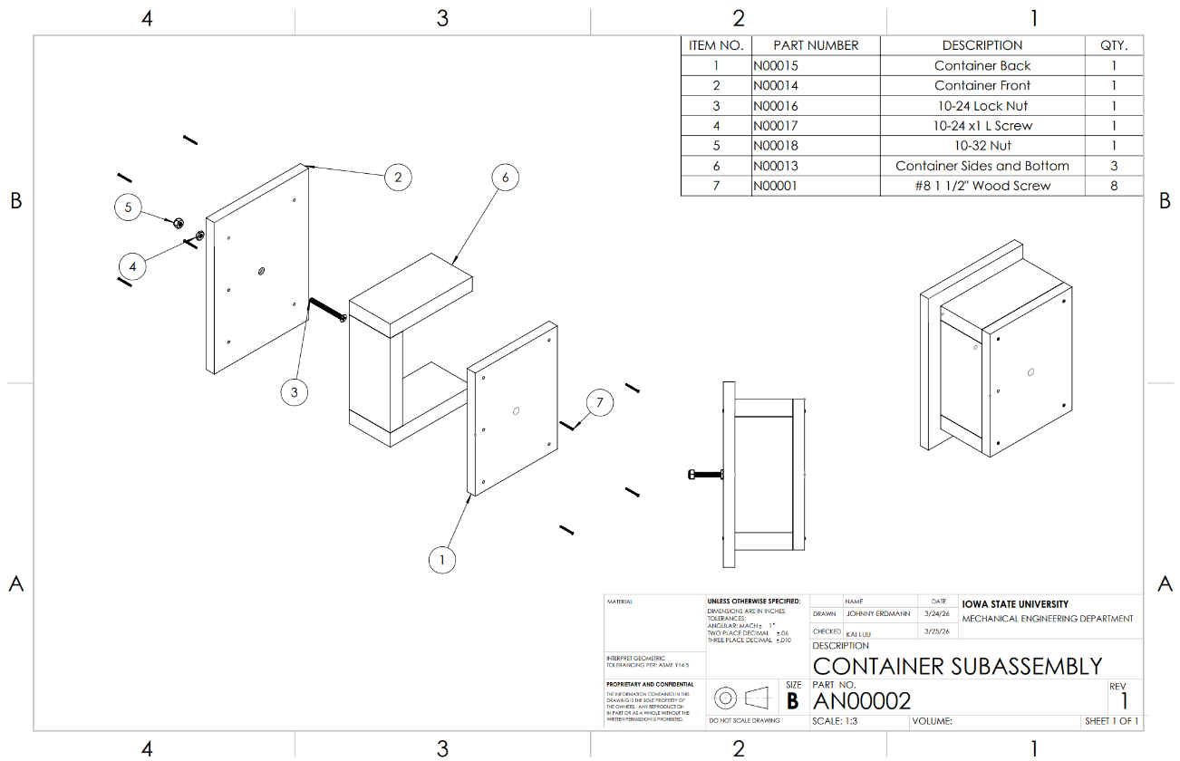
Figure 11. Container Subassembly

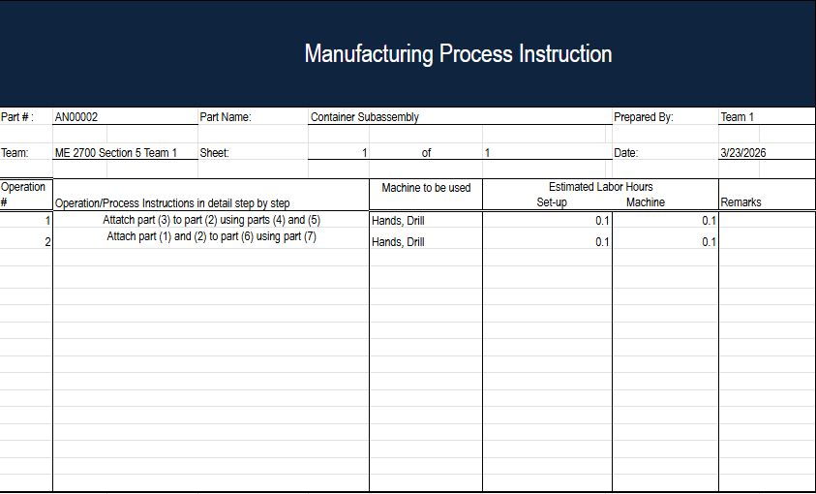
Figure 12. Container Subassembly MPI

The third subassembly, the roller plate subassembly (shown in Figure 13), is a basic plate with 4 small drilled holes and 2 larger holes for two bearings to be inserted. This assembly used the same basic woodworking tools as the two subassemblies above, but also a vise to assemble the roller plate itself. The process for assembling it is also shown below (Figure 14).
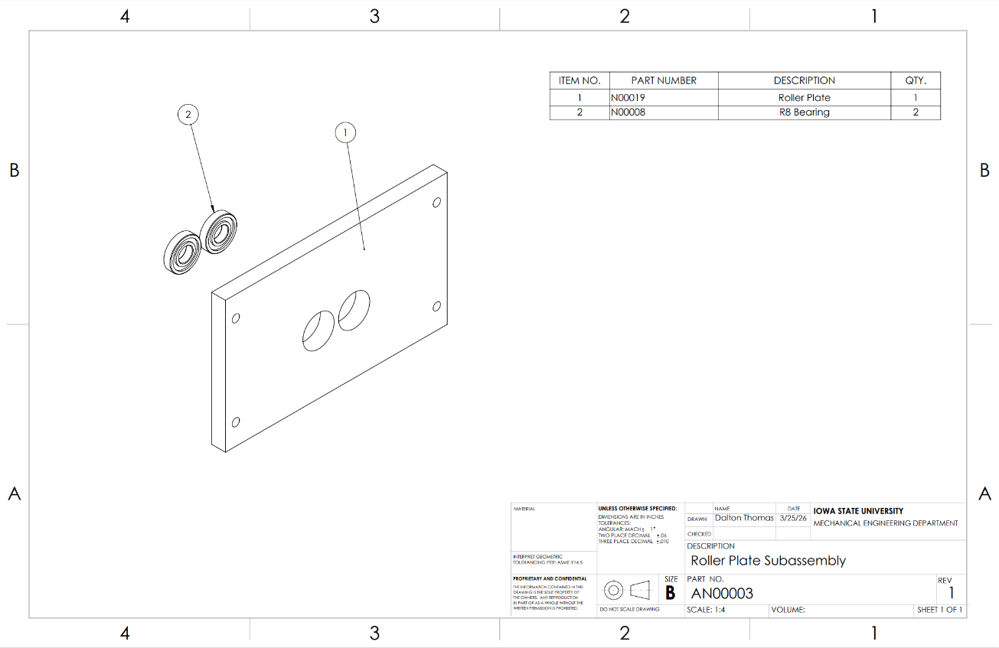
Figure 13. Roller Plate Subassembly

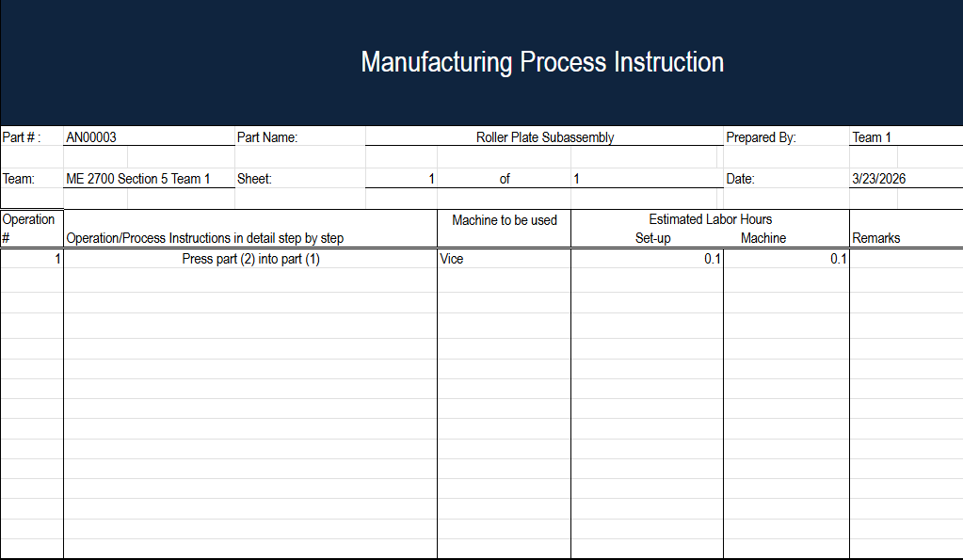
Figure 14. Roller Plate Subassembly MPI

The fourth subassembly, the hand crank subassembly (shown in Figure 15), is a basic handle-and-arm mechanism made of a cylindrical handle and a rectangular arm with drilled holes for hardware to be inserted, allowing it to assemble and connect with the grinder subassembly. This subassembly uses the three basic woodworking tools, as well as the horizontal band saw and the vice. The process for assembling it is shown below as well (Figure 16).

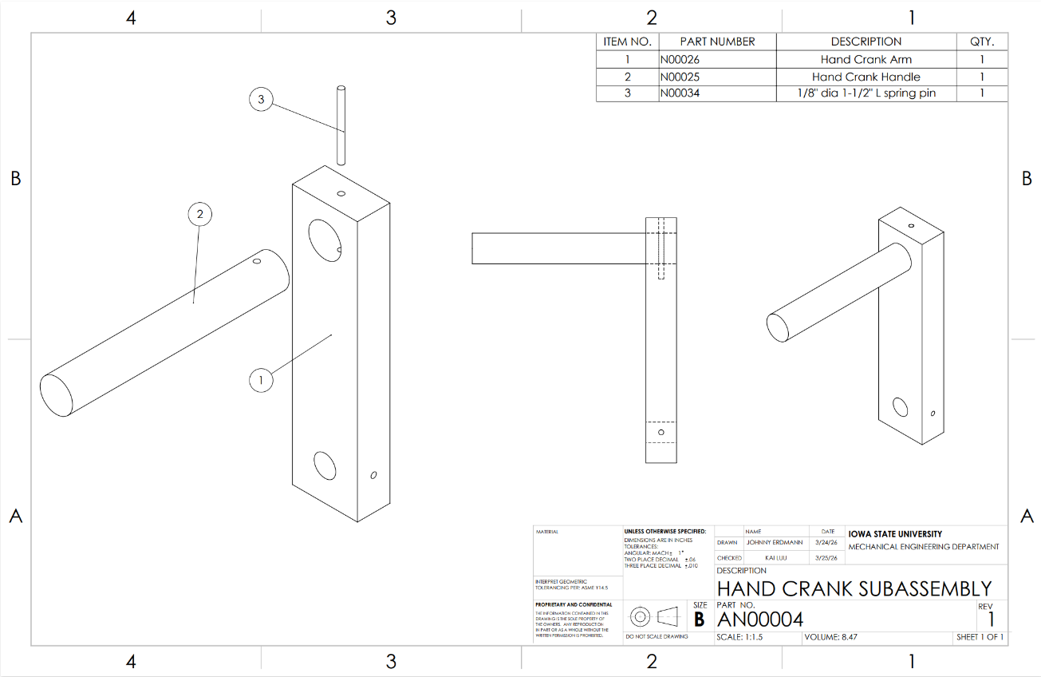
Figure 15. Hand Crank Subassembly

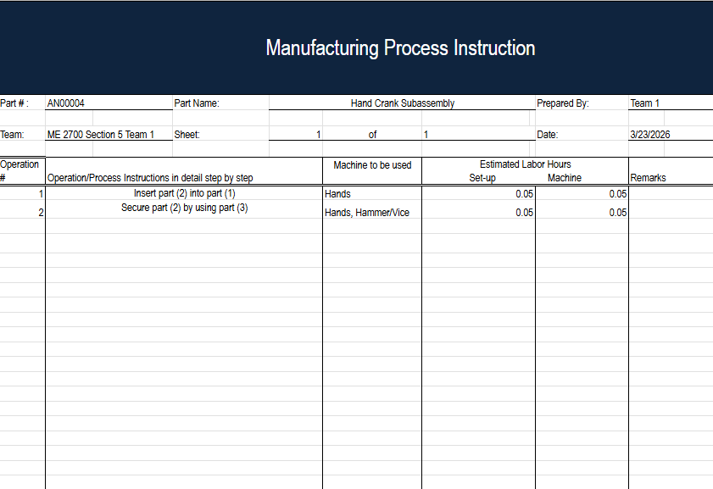
Figure 16. Hand Crank Subassembly MPI

The fifth subassembly, the clamp subassembly (shown in Figure 17), consists of a basic cylindrical rod with a cylinder plate, both connected by 2 bolts. This subassembly is to be assembled to the shell later, so the user can clamp the prototype to any surface needed and tighten it accordingly. This subassembly uses the horizontal bandsaw, drill press, and vertical bandsaw. The process for assembling it is shown below (Figure 18).

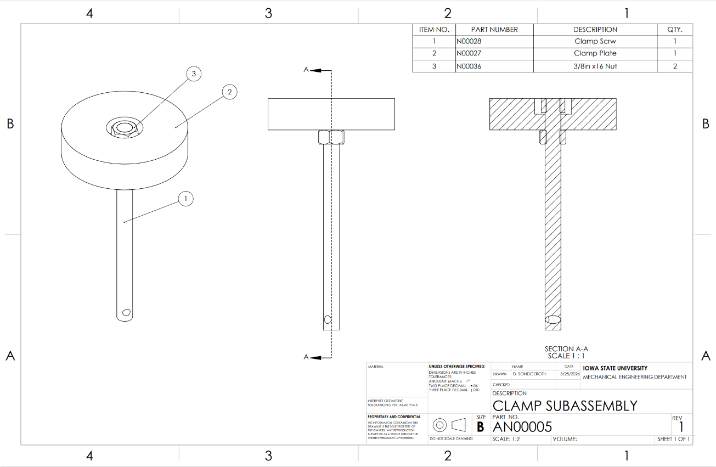
Figure 17. Clamp Subassembly

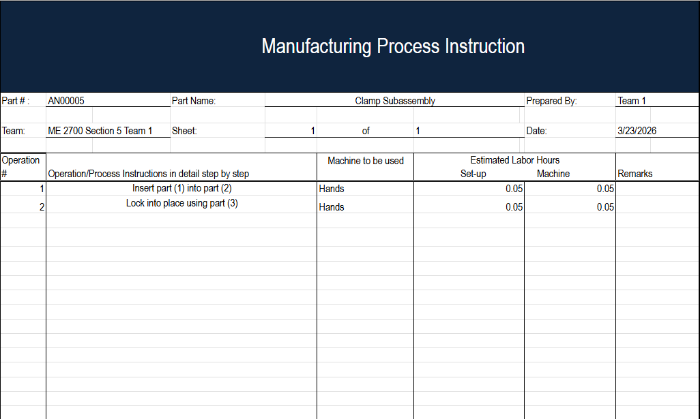
Figure 18. Clamp Subassembly MPI

The sixth subassembly, the grinder subassembly (shown in Figure 19), is the main part of the whole prototype, the part that actually grinds the grain. This subassembly is made of a knurled rod and a back rod, all pinned together so it stays. Lastly, it has set screws to secure the gear shaft when it is inserted. This subassembly uses a metal lathe to make the knurled rod and the back rod, a horizontal band saw, and a drill press. The assembly process is shown below (Figure 20).

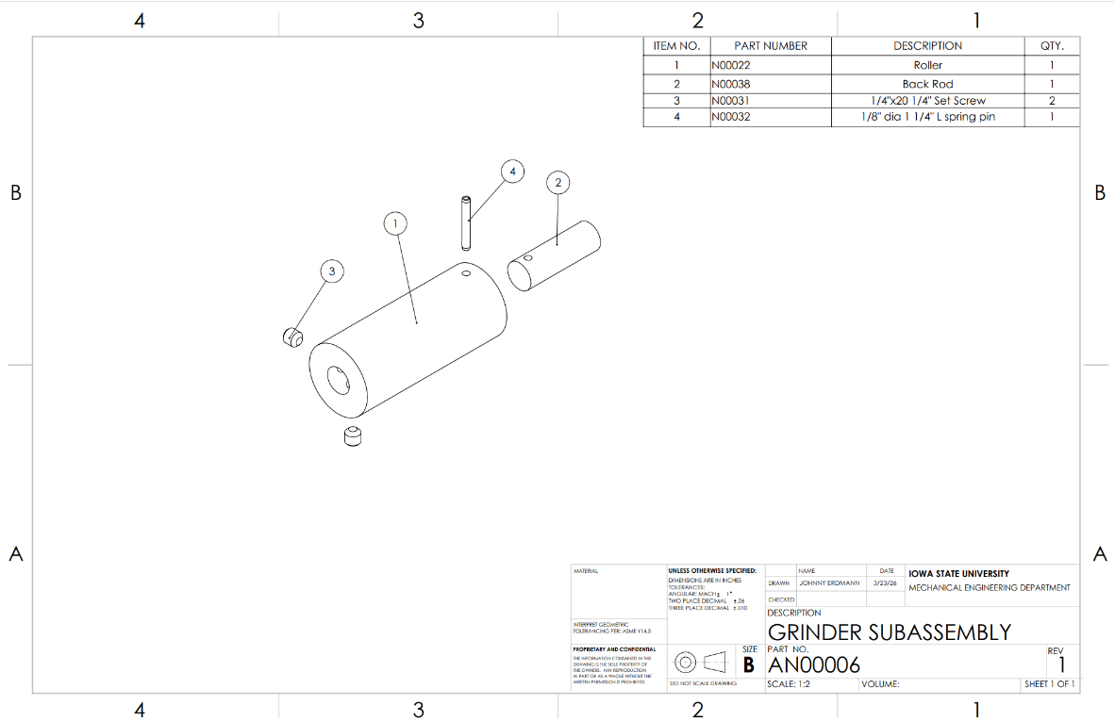
Figure 19. Grinder Subassembly

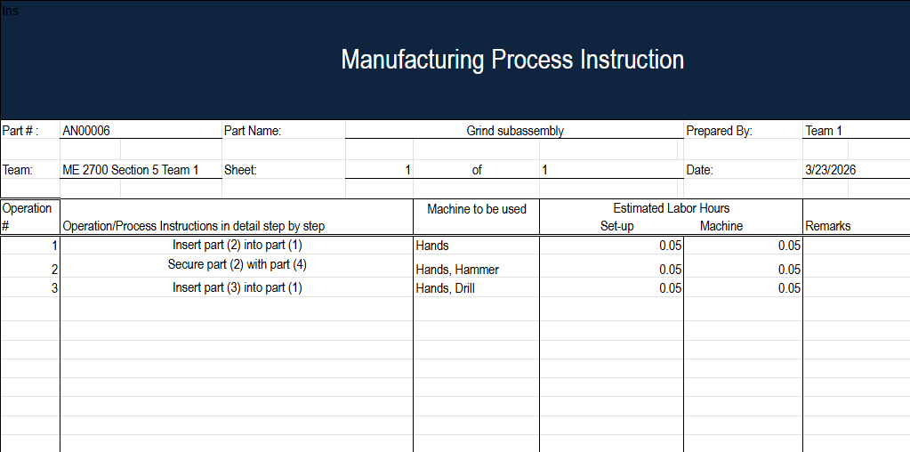
Figure 20. Grinder Subassembly MPI

The seventh subassembly, the driven rod subassembly (shown in Figure 21), is a rod with a gear on it and a pin to secure it. This subassembly is crucial because it drives the second knurled rod and makes it spin. This subassembly uses a horizontal bandsaw, drill press, miter saw, vertical band saw, table saw, and vice. The process for assembling it is shown below (Figure 22).
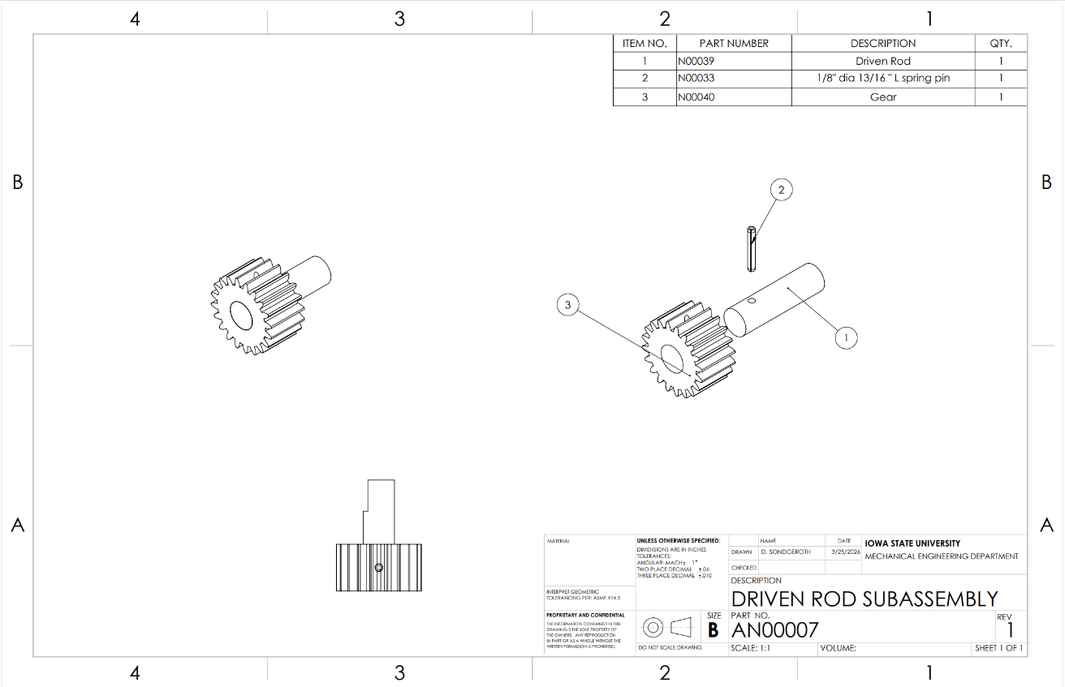
Figure 21. Driven Rod Subassembly

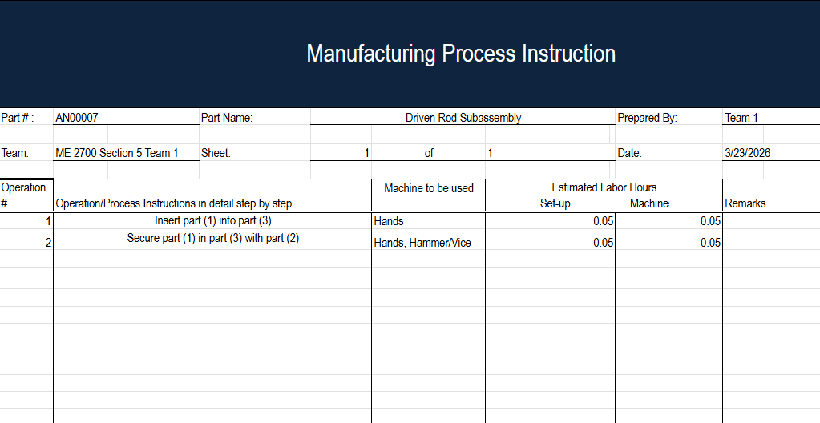
Figure 22. Driven Rod Subassembly MPI

The last subassembly, the driving rod subassembly (shown in Figure 23), is very similar to the driven rod subassembly: it is a rod with a gear that is pinned in place; the gear is in the middle to leave space for the hand crank to be assembled to it. This assembly used the same tools as the driven rod subassembly. The process for assembling it is also shown below (Figure 24).
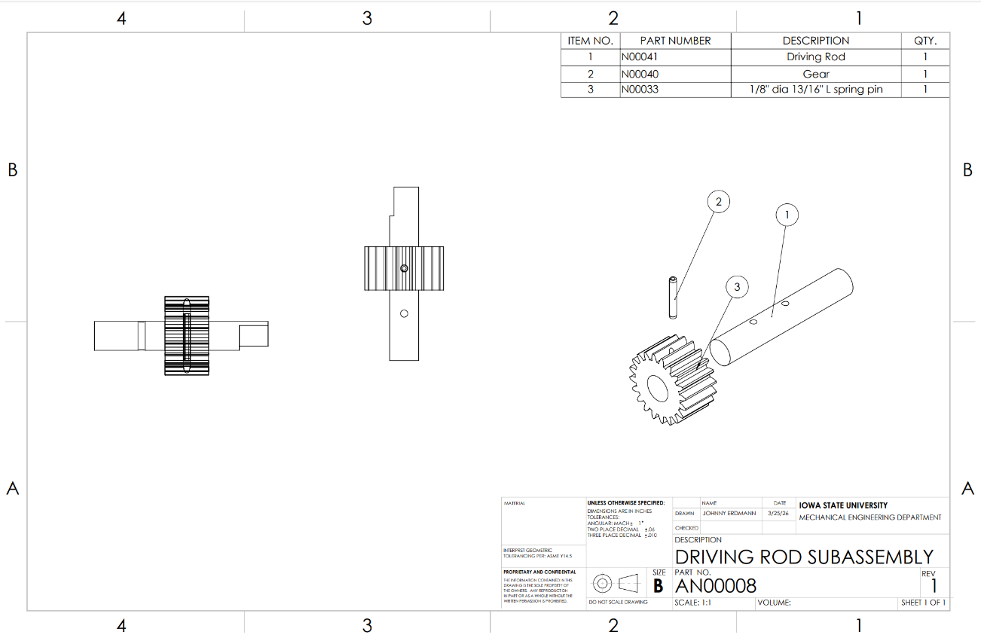
Figure 23. Driving Rod Subassembly

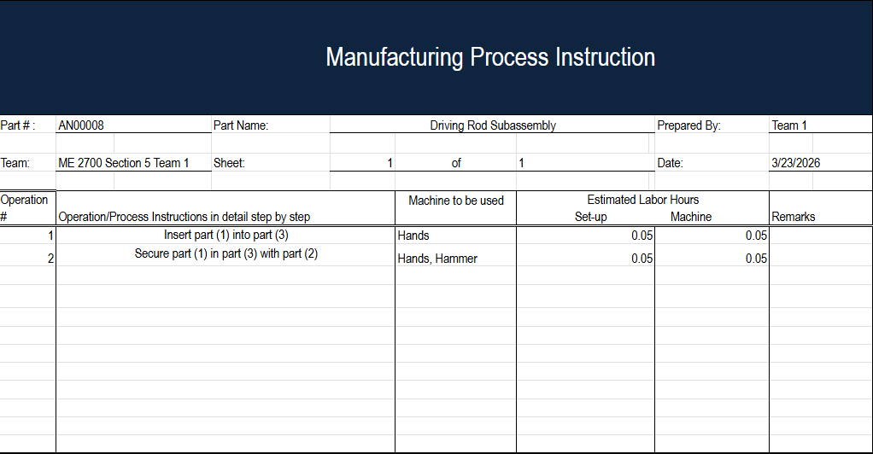
Figure 24. Driving Rod Subassembly MPI

Finally, using all the subassemblies, the team will assemble the final grain mill (shown in Figures 25-26). When fully assembled, the grain mill works by having the user insert millet into the funnel while cranking the hand crank; the driving rod turns the first knurled rod, which in turn turns the driven rod, which turns the other knurled rod. The grain then falls into the container subassembly for the user to collect. The final grain mill uses only your hands to assemble and is fairly easy to put together. The process for assembling it is shown below (Figure 27).
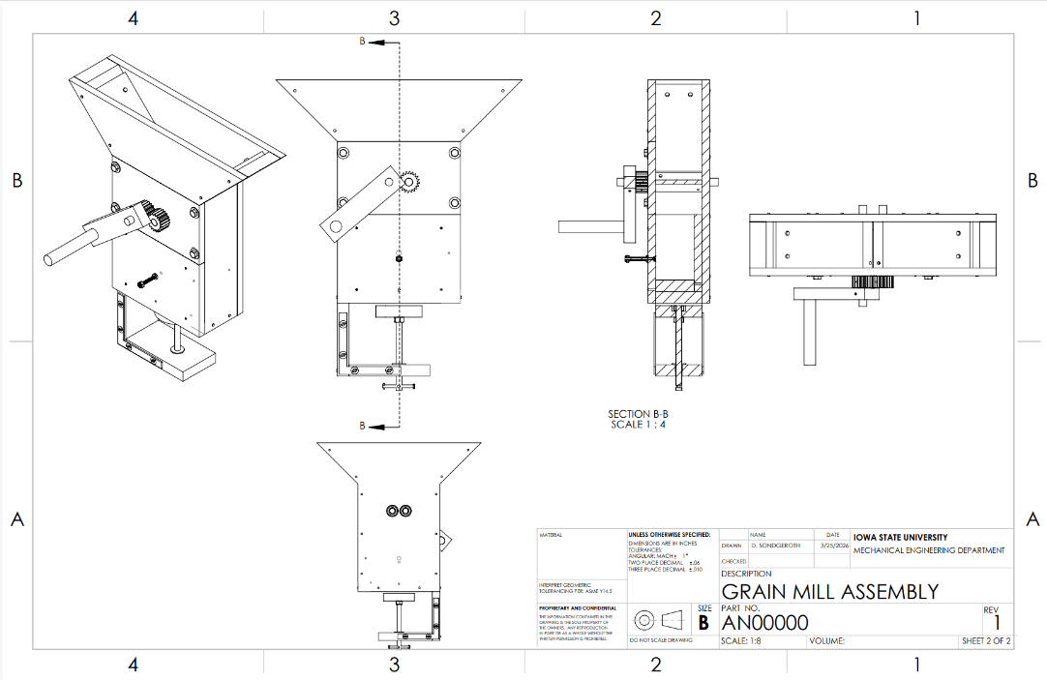
Figure 25. Grain Mill Assembly Assembled
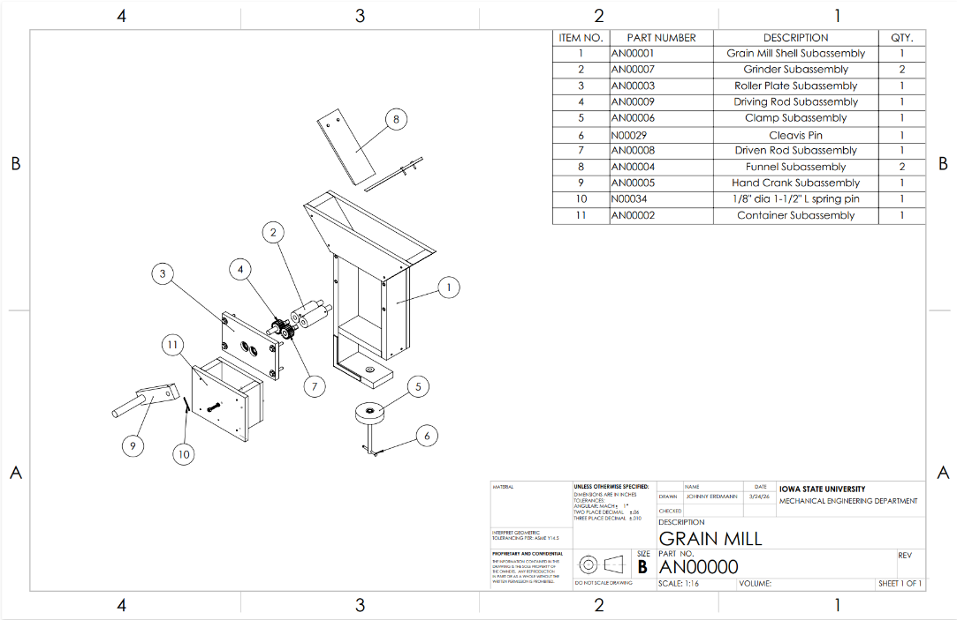
Figure 26. Grain Mill Assembly Exploded

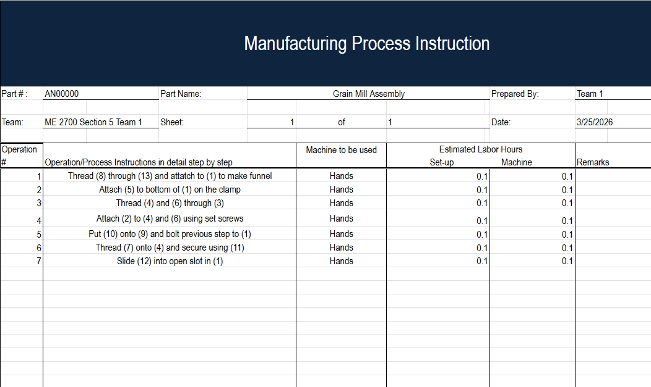
Figure 27. Grain Mill Assembly MPI

Given the overview of the fabrication process, the most crucial parts are definitely the knurled rod and the subassemblies directly connected to it (all parts are shown in the BOM in Table 10-11). This is because it makes or breaks the whole prototype; if one subassembly or part is off, the whole thing is as well. So the team needs to go extra slow on those parts, make them precise, and think about tolerances and such. The steps of the fabrication process that will take the most time are definitely assembling the whole thing and getting the actual knurled rod manufactured. This is because when assembling the prototype, the team may have to assemble, unassemble, and reassemble multiple times to get it correct or the way the team wants it. Also, the knurled rod is a task the team gives to the Boyd lab professionals, so depending on their workload, it could take a decent amount of time as well.

Table 10. Bill of Materials 1/2
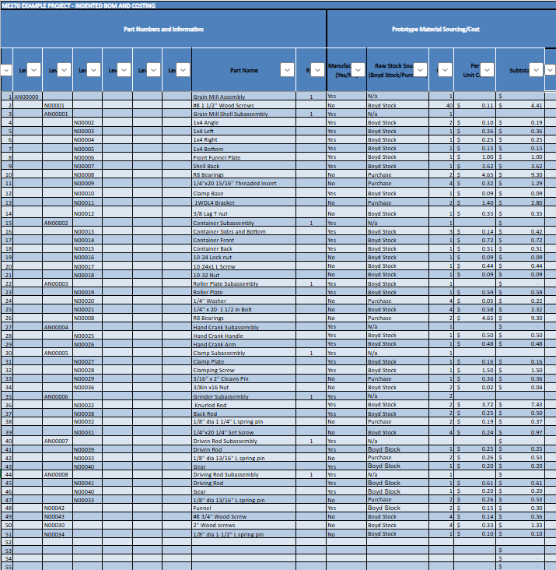
Table 11. Bill of Materials 2/2
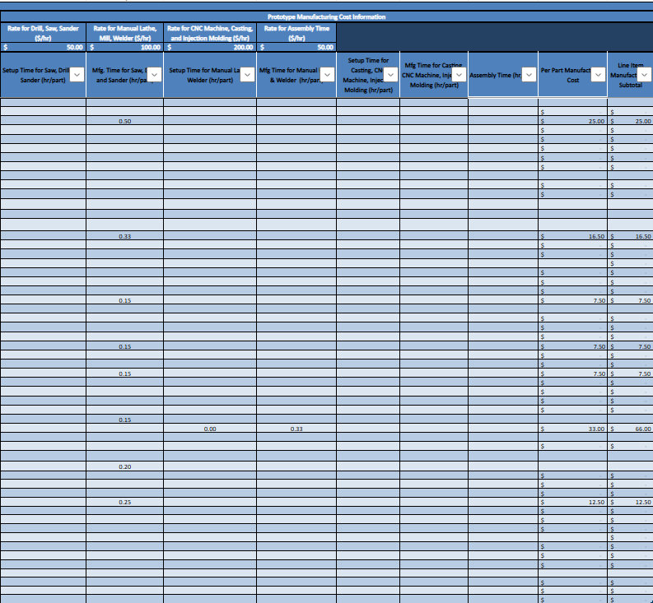
During the design review with the Boyd lab professionals, they gave us many good tips on how to make it easier for us to assemble and for manufacturers to read the drawings by adding more views and correct dimensions. Overall, though their tips didn’t necessarily have much impact on the final design, they gave us many ideas to make the team’s lives easier. One tip was just to assemble certain parts before others so that it wouldn’t mess up everything. Some of these parts were the clamp assembly on the shell, the grinder subassembly, the roller plate subassembly, and everything else.

7. Testing Plan
The testing plan is to run three tests on the prototype. The first test will be to measure the prototype's milling rate in lbs/min. This test will be conducted by first assembling the entire prototype, clamping it to the table, then having someone pour grain into the funnel while someone cranks the hand crank at a consistent speed and simultaneously starts a stopwatch. Lastly, after 1 min, have the person stop the stopwatch, record the grain weight, and calculate the milling rate (mass/time). The expected result for this test is for it to grind about 3 lbs per minute; this is based on knowing that knurled rods increase grinding efficiency, and if the team assembles it right, the team should be able to get about that much, and if the team does, it indicates that the prototype has an effective milling rate. The second test will be a simple eye test to see if the prototype grinds grain well, so the outcome will be yes/no. This test will be conducted by first assembling the entire prototype, clamping it to the table, then having someone pour grain into the funnel while someone is also cranking the hand crank at a consistent speed, and then lastly stopping cranking when all the grain is ground and having someone record whether the grain is ground well or not, indicating a yes/no answer. The expected result for this test is yes, as said above, and the knurled rods are good for grinding grain, so if it works properly, it should result in a yes. The third test will be to measure the prototype’s funnel capacity. This test will be conducted in one of two ways. The first way is to assemble the entire prototype, clamp it to the table, and then cover the funnel so no grain can fall. Then pour the grain into the funnel until it is full, then collect it and measure its volume using a graduated container. The other way to conduct this test is to once again assemble the entire prototype, clamp it to the table, measure the inside of the funnel, and calculate the volume of the space to determine how much grain it could hold. The expected result for this test is that the funnel holds about 710 cm³, and it should hold that amount as planned all the way back at the project charter, which was one of the deliverables.

Test 1: For the first test, the team will collect only the weight of the ground grain and the time it takes to grind it. The only material the team will need is grain (millet) to be ground. The equipment the team needs for this test is a stopwatch/timer to record time and a scale to measure the weight of the ground grain. The testing time for this test is about 5-10 minutes. The milling rate test ensures the product is efficient and already competes with current market mills. The relevant mathematical model for the first test is just milling rate = m/t, where m = mass (lbs) and t = time (s). This test has many parameters: the dependent variable is the milling rate; the varied parameter is crank speed (rev/min); and the constant parameters are the type of grain and the same mill assembly.

Test 2: For the second test, the only data collected will be a yes/no answer on whether the grain is ground. The only material the team needs for this test is grain (millet). The equipment the team needs for this test is just a pair of eyes to judge whether or not the grain is ground. The testing time for this test is about 5-10 minutes. The grinding test evaluates the biggest part of the prototype, ensuring that it actually grinds grain well; if it doesn’t, this whole project is almost pointless. The second test’s math model is just F-applied >= F-required, where F-applied is the force applied by the knurled rods on the grain, generated by the hand crank, and F-required is the force required to break down the grain. The parameters for this test are the dependent variable, grinding outcome (yes/no); the varied parameters, applied force (lbf) and crank speed (rev/min); and the constant parameters, type of grain, same grain size, and same mill assembly.

Test 3: For the third test, the team collects only funnel volume (i.e., funnel capacity). The only material the team needs for this test is also grain (millet). The equipment the team needs for this test is a graduated container to measure the grain volume or a tape measure if another method is used. The testing time for this test is also 5-10 minutes. The funnel capacity test checks whether the team can hold the amount of grain specified at the start, which the team used to base the design on, so this test also shows whether the team built the prototype correctly. The math model for the third test, if the team uses the second method, is Volume = 2(V1) + V2, where Volume is the total volume or capacity of the funnel, V1 is the volume of one of the triangular sides, and V2 is the volume of the square center. The parameters for this test are the dependent variable (funnel capacity in cm^3), the varied parameters (grain packing difference and measurement errors), and the constant parameters (grain type and the same mill assembly).

8. Profit and Loss Analysis and Business Plan
The hand-crank grain mill will be made using simple tools and locally available materials in Nigeria, making it practical and repairable if needed. The main material of the prototype is wood because it is cheap, lightweight, and easy to repair or replace, as mentioned. However, key components like the knurled rods, screws, brackets, bolts, and everything that isn’t wood will be purchased and used that way without much modification, except for the knurled rods; holes will be drilled into them. Manufacturing will take place in the United States, using basic tools such as drills and hammers, as well as machines including drill presses, miter saws, vertical and horizontal bandsaws, table saws, and metal lathes. All these tools and machines will be purchased. The finished prototypes would then be shipped to Nigeria (target market), where they can be distributed to local markets or smaller retailers, allowing customers to purchase them as needed. Market research showed that similar grain mills range from about $55 to $250, so this design targets a price of $50 to remain affordable and competitive. The projected number of units sold was based on the time required to manufacture one, the high demand for grain mills in Nigeria, and the need for an affordable alternative (Sources 2, 14-18). The team would achieve profits in all three years based on the model (shown in Figure 28). In the first year, the team would produce the least number of units, at 60, so the team would price it higher to make up for that, so the team would price the prototype at $60. As the years go on, the team will produce more units, specifically 66 and 73, while lowering the prototype price by $5 each year. By year 3, the team will achieve the goal of pricing the prototype at $50.

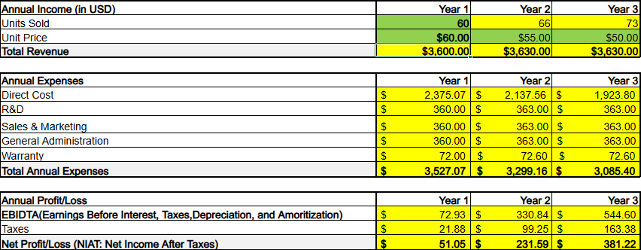
Figure 28. Profit and Loss Table

Overall, the target is very achievable. At first, there are many costs, like tools and machines, but as the team makes more units, the team profits more. But with the demand for the product, the result is a very realistic and achievable profit.

The prototype shows strong potential for success due to its alignment with key user needs, low cost, fully manual operation, compact design, and more. However, durability concerns, particularly with frequently used wood components, pose a significant threat. Also, competition from more expensive but more durable mills could cause many customers to pay more to get something more durable or better.

Three design changes that could reduce the product's cost are minimizing components, reducing the frame material, and using a smaller grinding mechanism. Minimizing components is definitely important, as reducing the number of screws, brackets, or components and making the prototype cleaner may not save much per prototype. Still, it will add up quickly over the years and save a significant amount of money. Reducing the frame would also save a bunch of money over the years, as shaving off a couple of inches of wood everywhere on the mill wouldn’t do much to structural mill stability, and it is just an easy way to save money. Making the grinding mechanism smaller would be an insane save, as that was the most expensive piece, because metalworking is an expensive process. If the team could find a smaller knurled rod that maintains the same efficiency, the team could save a bunch of dollars over the years.

The prototype design supports all three pillars of sustainability: environmental, social, and economic. First, from an environmental perspective, the design is fully human-operated, eliminating the need for electricity. which is important because unreliable power grids are a significant problem in rural Nigeria. In the long run, the prototype will also reduce emissions. Also, the use of simple materials such as wood and other basic metals lowers environmental impacts compared to complex manufactured materials. Socially, the product is designed for rural communities in Nigeria, where electricity is unreliable, which allows users to process their own grain independently. Its simple design improves ease of use, maintenance, and repair, making it more accessible and suitable for long-term use; if it breaks down, it can be easily repaired with materials that almost anyone can find. Economically, the prototype targets a cost of about $50, making it affordable for households while still allowing for potential profit if produced and sold at a large scale.

Despite those strengths, several design changes could further improve sustainability. First, the most obvious is that using fewer resources could lower the prototype's price, further benefiting customers economically. Second, the roller plate is already removable for cleaning, which supports maintainability, but there is a better way to design it with hinges instead of built-in, which would also make the whole prototype easier to reassemble. All parts are easy to replace, but some require disassembling much of the prototype, so finding a way to make it easier would make the product more user-friendly and sustainable. Lastly, if the team sources all materials from Nigeria, they can use the exact materials they would have while also supporting local economies.

These design modifications can also improve the balance between the three pillars of sustainability. For example, using locally sourced materials benefits the local economy and improves accessibility, as the team is using the exact same materials they would have access to for repairs. An easily disassembled design also improves environmental sustainability, as they can just replace a part if it breaks instead of buying a new prototype. Also, this implementation reduced users' long-term costs for the same reason: they do not have to buy a new prototype; they just have to replace the part. Additionally, this improves efficiency and usability, such as the roller plate being easily removable, which makes it easier to clean and replace certain parts, thereby improving the social aspect of the prototype.

9. Fabrication Process and Test Results

The processes outlined in the fabrication remained largely untouched. The only significant change was using the mill to drill holes straight through the cylindrical metal components. The original plan was to use the drill press. While the drill press would still work, the mill saved a lot of time, reducing some costs. All wooden parts took significantly less time to fabricate than expected. Most of them were budgeted around 40 minutes and ended up taking 15 minutes on the machines. However, most of the time, the metal components were accurate. Filling the notches on the ends of the metal rods took more work than anticipated, but it was completed roughly on time. The primary problems encountered were material issues, gear tolerances, and burrs forming after cuts on metal components. The primary material issue was the splitting and warping of wooden components. Those parts remained within tolerances, so the issue was ignored. Gear tolerances were more problematic. A lot of touch-up work with needle files was required to make them mesh properly. The final issue the team encountered was the burrs on the metal parts. This issue was solved by filing the parts in question after the cut.

The team conducted three main tests for the prototype (data shown in Table 6): the milling rate test, a grinding performance test, and a funnel capacity test. The milling rate test showed that the prototype ground efficiently, exceeding the target of 1 lb/min and achieving 0.8 lbs in 40 seconds, or 1.2 lb/min. The grinding performance test also went hand in hand with the milling rate test; if the milling rate test went poorly, this test would likely get a NO as well. However, since the milling rate test went extremely well, this test also went extremely well, exceeding expectations. The team did not expect the mill to grind this well, but in the end, the grinding performance test was a huge success and received a YES. The last test, the funnel capacity test, verified that the funnel could hold the expected 710 cm³; in fact, it was much more than the team expected, with a capacity of 1885 cm³, which is also a huge success, almost 3x the standard. Some adjustments were made during testing, such as when the team had to do the funnel capacity test, the team did that one last, so the team actually had 0 grain left to do that test, so the team pivoted and just measured it and calculated it using geometry, in which the team assumed no loss of volume by grain packing and such, but the number was so far above the goal that either way it would’ve still been a huge success. Other than that, the tests were pretty straightforward, and the team made a few adjustments. Overall, the test results were fairly close to the predictions for the milling rate test, but, honestly, way off for the capacity, in a good way. Overall, though all expectations were exceeded, the prototype passed all tests with flying colors. Honestly, as the team passed all tests with flying colors, the team doesn’t have many design revisions for the prototype; the only thing the team would change for a future prototype is to make the gears out of a more sturdy material, as the wear on them from the tests isn’t much, but over time, it could be a problem. Overall, though, testing showed that the design exceeded expectations, and the team is all very proud of the prototype they have produced.

Table 6. Testing Data Table
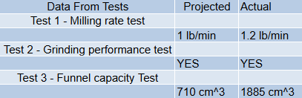

10. Executive Summary

